

**PROJECT RROPOSAL OF**

**Computer Application in Engineering Design Lab**

|  |  |
| --- | --- |
| **GROUP MEMBERS NAME:** | **Zainab-Binte-Hassan**  **Rabia** |
| **GROUP MEMBERS ID:** | **FA17-BECE-0020**  **FA17-BECE-2001** |
| **TEACHER NAME:** | **Ma’am Rafia Shaikh** |
| **SECTION:** | **AM(CSE)** |
| **PROJECT TOPIC:** | **Controlling of DC Motor** |

**OBJECTIVE OF YOUR PROJECT:**

The **objective** of this project is to increase the speed of **DC motor by** the help of **Arduino, MATLAB** and L293D- motor driver.

**PROJECT SHORT DESCRIPTION:**

Components we are using in this project are:

* MATLAB installed Laptop (Preference: R2016a or above versions)
* Arduino UNO
* DC Motor
* L293D- motor driver

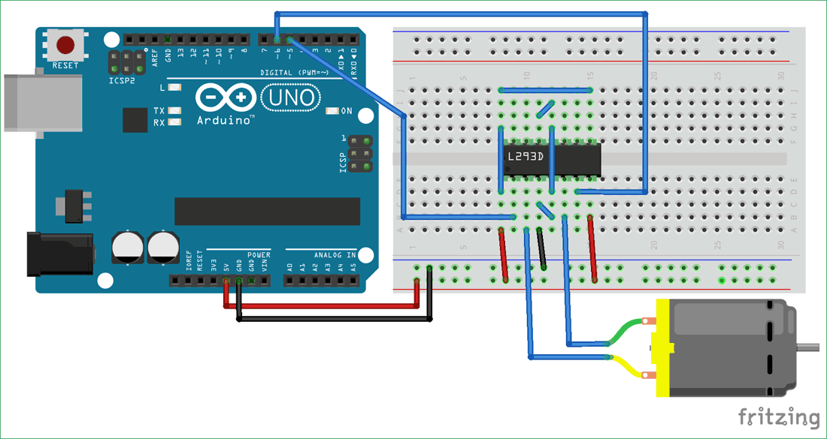

MATLAB and Arduino are used to control DC motor. L293D IC  is a typical Motor Driver IC which allows the [DC motor](https://www.elprocus.com/dc-motor-basics-types-application/) to drive on any direction. This IC consists of 16-pins which are used to control a set of two DC motors instantaneously in any direction. It means, by using a L293D IC we can control two DC motors. As well, this IC can drive small and quiet big motors.

**FLOW CHART:**

